PYTHON
Python is a general-purpose interpreted, interactive, object-oriented, and high-level programming language. An interpreted language, Python has a design philosophy that emphasizes code readability (notably using whitespace indentation to delimit code blocks rather than curly brackets or keywords), and a syntax that allows programmers to express concepts in fewer lines of code than might be used in languages such as C++or Java. It provides constructs that enable clear programming on both small and large scales. Python interpreters are available for many operating systems. CPython, the reference implementation of Python, is open source software and has a community-based development model, as do nearly all of its variant implementations. CPython is managed by the non-profit Python Software Foundation. Python features a dynamic type system and automatic memory management. It supports multiple programming paradigms, including object-oriented, imperative, functional and procedural, and has a large and comprehensive standard library

What is Python

Python is a popular programming language. It was created by Guido van Rossum, and released in 1991.
It is used for:
- web development (server-side),
- software development,
- mathematics,
- system scripting.

What can Python do
- Python can be used on a server to create web applications.
- Python can be used alongside software to create workflows.
- Python can connect to database systems. It can also read and modify files.
- Python can be used to handle big data and perform complex mathematics.
- Python can be used for rapid prototyping, or for production-ready software development.

Why Python
- Python works on different platforms (Windows, Mac, Linux, Raspberry Pi, etc).
- Python has a simple syntax similar to the English language.
- Python has syntax that allows developers to write programs with fewer lines than some other programming languages.
- Python runs on an interpreter system, meaning that code can be executed as soon as it is written. This means that prototyping can be very quick.
- Python can be treated in a procedural way, an object-orientated way or a functional way.

Good to know
- The most recent major version of Python is Python 3, which we shall be using in this tutorial. However, Python 2, although not being updated with anything other than security updates, is still quite popular.
- In this tutorial Python will be written in a text editor. It is possible to write Python in an Integrated Development Environment, such as Thonny, Pycharm, Netbeans or Eclipse which are particularly useful when managing larger collections of Python files.

Python Syntax compared to other programming languages
- Python was designed for readability, and has some similarities to the English language with influence from mathematics.
- Python uses new lines to complete a command, as opposed to other programming languages which often use semicolons or parentheses.
- Python relies on indentation, using whitespace, to define scope; such as the scope of loops, functions and classes. Other programming languages often use curly-brackets for this purpose.
Python Install
Many PCs and Macs will have python already installed.
To check if you have python installed on a Windows PC, search in the start bar for Python or run the following on the Command Line (cmd.exe):
C:\Users\Your Name>python --version
To check if you have python installed on a Linux or Mac, then on linux open the command line or on Mac open the Terminal and type:
python --version
If you find that you do not have python installed on your computer, then you can download it for free from the following website: https://www.python.org/
Python Quickstart
Python is an interpreted programming language, this means that as a developer you write Python (.py) files in a text editor and then put those files into the python interpreter to be executed.
The way to run a python file is like this on the command line:
C:\Users\Your Name>python helloworld.py
Where "helloworld.py" is the name of your python file.
Let's write our first Python file, called helloworld.py, which can be done in any text editor.
helloworld.py
print("Hello, World!")
Simple as that. Save your file. Open your command line, navigate to the directory where you saved your file, and run:
C:\Users\Your Name>python helloworld.py
The output should read:
Hello, World!
Congratulations, you have written and executed your first Python program.
The Python Command Line
To test a short amount of code in python sometimes it is quickest and easiest not to write the code in a file. This is made possible because Python can be run as a command line itself.
Type the following on the Windows, Mac or Linux command line:
C:\Users\Your Name>python
Or, if the "python" command did not work, you can try "py":
C:\Users\Your Name>py
From there you can write any python, including our hello world example from earlier in the tutorial:
C:\Users\Your Name>python
Python 3.6.4 (v3.6.4:d48eceb, Dec 19 2017, 06:04:45) [MSC v.1900 32 bit (Intel)] on win32
Type "help", "copyright", "credits" or "license" for more information.
>>> print("Hello, World!")
Which will write "Hello, World!" in the command line:
C:\Users\Your Name>python
Python 3.6.4 (v3.6.4:d48eceb, Dec 19 2017, 06:04:45) [MSC v.1900 32 bit (Intel)] on win32
Type "help", "copyright", "credits" or "license" for more information.
>>> print("Hello, World!")
Hello, World!
Whenever you are done in the python command line, you can simply type the following to quit the python command line interface:
exit()
Virtual Environments and Packages
Introduction
Python applications will often use packages and modules that don’t come as part of the standard library. Applications will sometimes need a specific version of a library, because the application may require that a particular bug has been fixed or the application may be written using an obsolete version of the library’s interface.
This means it may not be possible for one Python installation to meet the requirements of every application. If application A needs version 1.0 of a particular module but application B needs version 2.0, then the requirements are in conflict and installing either version 1.0 or 2.0 will leave one application unable to run.
The solution for this problem is to create a virtual environment, a self-contained directory tree that contains a Python installation for a particular version of Python, plus a number of additional packages.
Different applications can then use different virtual environments. To resolve the earlier example of conflicting requirements, application A can have its own virtual environment with version 1.0 installed while application B has another virtual environment with version 2.0. If application B requires a library be upgraded to version 3.0, this will not affect application A’s environment.
Creating Virtual Environments
The module used to create and manage virtual environments is called venv. venv will usually install the most recent version of Python that you have available. If you have multiple versions of Python on your system, you can select a specific Python version by running python3 or whichever version you want.
To create a virtual environment, decide upon a directory where you want to place it, and run the venv module as a script with the directory path:
python3 -m venv tutorial-env
This will create the tutorial-env directory if it doesn’t exist, and also create directories inside it containing a copy of the Python interpreter, the standard library, and various supporting files.
A common directory location for a virtual environment is .venv. This name keeps the directory typically hidden in your shell and thus out of the way while giving it a name that explains why the directory exists. It also prevents clashing with .env environment variable definition files that some tooling supports.
Once you’ve created a virtual environment, you may activate it.
On Windows, run:
tutorial-env\Scripts\activate.bat
On Unix or MacOS, run:
source tutorial-env/bin/activate
(This script is written for the bash shell. If you use the csh or fish shells, there are alternate activate.csh and activate.fish scripts you should use instead.)

Activating the virtual environment will change your shell’s prompt to show what virtual environment you’re using, and modify the environment so that running python will get you that particular version and installation of Python. For example:
$ source ~/envs/tutorial-env/bin/activate
(tutorial-env) $ python
Python 3.5.1 (default, May 6 2016, 10:59:36)
...
>>> import sys
>>> sys.path
['', '/usr/local/lib/python35.zip', ...,
'~/envs/tutorial-env/lib/python3.5/site-packages']
>>>
12.3. Managing Packages with pip
You can install, upgrade, and remove packages using a program called pip. By default pip will install packages from the Python Package Index, <https://pypi.org>. You can browse the Python Package Index by going to it in your web browser, or you can use pip’s limited search feature:
(tutorial-env) $ pip search astronomy
skyfield - Elegant astronomy for Python
gary - Galactic astronomy and gravitational dynamics.
novas - The United States Naval Observatory NOVAS astronomy library
astroobs - Provides astronomy ephemeris to plan telescope observations
PyAstronomy - A collection of astronomy related tools for Python.
...
pip has a number of subcommands: “search”, “install”, “uninstall”, “freeze”, etc. (Consult the Installing Python Modules guide for complete documentation for pip.)
You can install the latest version of a package by specifying a package’s name:
(tutorial-env) $ pip install novas
Collecting novas
Downloading novas-3.1.1.3.tar.gz (136kB)
Installing collected packages: novas
Running setup.py install for novas
Successfully installed novas-3.1.1.3
You can also install a specific version of a package by giving the package name followed by == and the version number:
(tutorial-env) $ pip install requests==2.6.0
Collecting requests==2.6.0
Using cached requests-2.6.0-py2.py3-none-any.whl
Installing collected packages: requests
Successfully installed requests-2.6.0
If you re-run this command, pip will notice that the requested version is already installed and do nothing. You can supply a different version number to get that version, or you can run pip install --upgrade to upgrade the package to the latest version:

(tutorial-env) $ pip install --upgrade requests
Collecting requests
Installing collected packages: requests
Found existing installation: requests 2.6.0
Uninstalling requests-2.6.0:
Successfully uninstalled requests-2.6.0
Successfully installed requests-2.7.0
pip uninstall followed by one or more package names will remove the packages from the virtual environment.

pip show will display information about a particular package:

(tutorial-env) $ pip show requests
---
Metadata-Version: 2.0
Name: requests
Version: 2.7.0
Summary: Python HTTP for Humans.
Home-page: http://python-requests.org
Author: Kenneth Reitz
Author-email: me@kennethreitz.com
License: Apache 2.0
Location: /Users/akuchling/envs/tutorial-env/lib/python3.4/site-packages
Requires:
pip list will display all of the packages installed in the virtual environment:

(tutorial-env) $ pip list
novas (3.1.1.3)
numpy (1.9.2)
pip (7.0.3)
requests (2.7.0)
setuptools (16.0)
pip freeze will produce a similar list of the installed packages, but the output uses the format that pip install expects. A common convention is to put this list in a requirements.txt file:

(tutorial-env) $ pip freeze > requirements.txt
(tutorial-env) $ cat requirements.txt
novas==3.1.1.3
numpy==1.9.2
requests==2.7.0
The requirements.txt can then be committed to version control and shipped as part of an application. Users can then install all the necessary packages with install -r:

(tutorial-env) $ pip install -r requirements.txt
Collecting novas==3.1.1.3 (from -r requirements.txt (line 1))
...
Collecting numpy==1.9.2 (from -r requirements.txt (line 2))
...
Collecting requests==2.7.0 (from -r requirements.txt (line 3))
...
Installing collected packages: novas, numpy, requests
Running setup.py install for novas
Successfully installed novas-3.1.1.3 numpy-1.9.2 requests-2.7.0
pip has many more options. Consult the Installing Python Modules guide for complete documentation for pip. When you’ve written a package and want to make it available on the Python Package Index, consult the Distributing Python Modules guide.
Cross Platform
platform.architecture(executable=sys.executable, bits='', linkage='')
Queries the given executable (defaults to the Python interpreter binary) for various architecture information.
Returns a tuple (bits, linkage) which contain information about the bit architecture and the linkage format used for the executable. Both values are returned as strings.

Values that cannot be determined are returned as given by the parameter presets. If bits is given as '', the sizeof(pointer) (or sizeof(long) on Python version < 1.5.2) is used as indicator for the supported pointer size.
The function relies on the system’s file command to do the actual work. This is available on most if not all Unix platforms and some non-Unix platforms and then only if the executable points to the Python interpreter. Reasonable defaults are used when the above needs are not met.
Note On Mac OS X (and perhaps other platforms), executable files may be universal files containing multiple architectures.
To get at the “64-bitness” of the current interpreter, it is more reliable to query the sys.maxsize attribute:
is_64bits = sys.maxsize > 2**32
platform.machine()
Returns the machine type, e.g. 'i386'. An empty string is returned if the value cannot be determined.
platform.node()
Returns the computer’s network name (may not be fully qualified!). An empty string is returned if the value cannot be determined.
platform.platform(aliased=0, terse=0)
Returns a single string identifying the underlying platform with as much useful information as possible.
The output is intended to be human readable rather than machine parseable. It may look different on different platforms and this is intended.

If aliased is true, the function will use aliases for various platforms that report system names which differ from their common names, for example SunOS will be reported as Solaris. The system_alias() function is used to implement this.
Setting terse to true causes the function to return only the absolute minimum information needed to identify the platform.
platform.processor()
Returns the (real) processor name, e.g. 'amdk6'.
An empty string is returned if the value cannot be determined. Note that many platforms do not provide this information or simply return the same value as for machine(). NetBSD does this.
platform.python_build()
Returns a tuple (buildno, builddate) stating the Python build number and date as strings.
platform.python_compiler()
Returns a string identifying the compiler used for compiling Python.
platform.python_branch()
Returns a string identifying the Python implementation SCM branch.
New in version 2.6.
platform.python_implementation()
Returns a string identifying the Python implementation. Possible return values are: ‘CPython’, ‘IronPython’, ‘Jython’, ‘PyPy’.
New in version 2.6.
platform.python_revision()
Returns a string identifying the Python implementation SCM revision.
New in version 2.6.
platform.python_version()
Returns the Python version as string 'major.minor.patchlevel'.
Note that unlike the Python sys.version, the returned value will always include the patchlevel (it defaults to 0).
platform.python_version_tuple()
Returns the Python version as tuple (major, minor, patchlevel) of strings.
Note that unlike the Python sys.version, the returned value will always include the patchlevel (it defaults to '0').
platform.release()
Returns the system’s release, e.g. '2.2.0' or 'NT' An empty string is returned if the value cannot be determined.
platform.system()
Returns the system/OS name, e.g. 'Linux', 'Windows', or 'Java'. An empty string is returned if the value cannot be determined.
platform.system_alias(system, release, version)
Returns (system, release, version) aliased to common marketing names used for some systems. It also does some reordering of the information in some cases where it would otherwise cause confusion.
platform.version()
Returns the system’s release version, e.g. '#3 on degas'. An empty string is returned if the value cannot be determined.

platform.uname()
Fairly portable uname interface. Returns a tuple of strings (system, node, release, version, machine, processor) identifying the underlying platform.
Note that unlike the os.uname() function this also returns possible processor information as additional tuple entry.
Entries which cannot be determined are set to ''.
Java Platform
platform.java_ver(release='', vendor='', vminfo=('', '', ''), osinfo=('', '', ''))
Version interface for Jython.
Returns a tuple (release, vendor, vminfo, osinfo) with vminfo being a tuple (vm_name, vm_release, vm_vendor) and osinfo being a tuple (os_name, os_version, os_arch). Values which cannot be determined are set to the defaults given as parameters (which all default to '').
Windows Platform
platform.win32_ver(release='', version='', csd='', ptype='')
Get additional version information from the Windows Registry and return a tuple (release, version, csd, ptype) referring to OS release, version number, CSD level (service pack) and OS type (multi/single processor).
As a hint: ptype is 'Uniprocessor Free' on single processor NT machines and 'Multiprocessor Free' on multi processor machines. The ‘Free’ refers to the OS version being free of debugging code. It could also state ‘Checked’ which means the OS version uses debugging code, i.e. code that checks arguments, ranges, etc.

Note This function works best with Mark Hammond’s win32all package installed, but also on Python 2.3 and later (support for this was added in Python 2.6). It obviously only runs on Win32 compatible platforms.
Win95/98 specific
platform.popen(cmd, mode='r', bufsize=None)
Portable popen() interface. Find a working popen implementation preferring win32pipe.popen(). On Windows NT, win32pipe.popen() should work; on Windows 9x it hangs due to bugs in the MS C library.
Mac OS Platform
platform.mac_ver(release='', versioninfo=('', '', ''), machine='')
Get Mac OS version information and return it as tuple (release, versioninfo, machine) with versioninfo being a tuple (version, dev_stage, non_release_version).
Entries which cannot be determined are set to ''. All tuple entries are strings.
Unix Platforms
platform.dist(distname='', version='', id='', supported_dists=('SuSE', 'debian', 'redhat', 'mandrake', ...))
This is an old version of the functionality now provided by linux_distribution(). For new code, please use the linux_distribution().
The only difference between the two is that dist() always returns the short name of the distribution taken from the supported_dists parameter.
Deprecated since version 2.6.
platform.linux_distribution(distname='', version='', id='', supported_dists=('SuSE', 'debian', 'redhat', 'mandrake', ...), full_distribution_name=1)
Tries to determine the name of the Linux OS distribution name.
supported_dists may be given to define the set of Linux distributions to look for. It defaults to a list of currently supported Linux distributions identified by their release file name.
If full_distribution_name is true (default), the full distribution read from the OS is returned. Otherwise the short name taken from supported_dists is used.
Returns a tuple (distname,version,id) which defaults to the args given as parameters. id is the item in parentheses after the version number. It is usually the version codename.
Note This function is deprecated since Python 3.5 and removed in Python 3.8. See alternative like the distro package.
New in version 2.6.
platform.libc_ver(executable=sys.executable, lib='', version='', chunksize=2048)
Tries to determine the libc version against which the file executable (defaults to the Python interpreter) is linked. Returns a tuple of strings (lib, version) which default to the given parameters in case the lookup fails.
Note that this function has intimate knowledge of how different libc versions add symbols to the executable is probably only usable for executables compiled using gcc. The file is read and scanned in chunks of chunksize bytes.
2. Using the Python Interpreter
2.1. Invoking the Interpreter
The Python interpreter is usually installed as /usr/local/bin/python3.8 on those machines where it is available; putting /usr/local/bin in your Unix shell’s search path makes it possible to start it by typing the command:
python3.8
to the shell. 1 Since the choice of the directory where the interpreter lives is an installation option, other places are possible; check with your local Python guru or system administrator. (E.g., /usr/local/python is a popular alternative location.)

On Windows machines where you have installed Python from the Microsoft Store, the python3.8 command will be available. If you have the py.exe launcher installed, you can use the py command. See Excursus: Setting environment variables for other ways to launch Python.
Typing an end-of-file character (Control-D on Unix, Control-Z on Windows) at the primary prompt causes the interpreter to exit with a zero exit status. If that doesn’t work, you can exit the interpreter by typing the following command: quit().
The interpreter’s line-editing features include interactive editing, history substitution and code completion on systems that support the GNU Readline library. Perhaps the quickest check to see whether command line editing is supported is typing Control-P to the first Python prompt you get. If it beeps, you have command line editing; see Appendix Interactive Input Editing and History Substitution for an introduction to the keys. If nothing appears to happen, or if ^P is echoed, command line editing isn’t available; you’ll only be able to use backspace to remove characters from the current line.
The interpreter operates somewhat like the Unix shell: when called with standard input connected to a tty device, it reads and executes commands interactively; when called with a file name argument or with a file as standard input, it reads and executes a script from that file.
A second way of starting the interpreter is python -c command [arg] ..., which executes the statement(s) in command, analogous to the shell’s -c option. Since Python statements often contain spaces or other characters that are special to the shell, it is usually advised to quote command in its entirety with single quotes.
Some Python modules are also useful as scripts. These can be invoked using python -m module [arg] ..., which executes the source file for module as if you had spelled out its full name on the command line.
When a script file is used, it is sometimes useful to be able to run the script and enter interactive mode afterwards. This can be done by passing -i before the script.

All command line options are described in Command line and environment.
Argument Passing
When known to the interpreter, the script name and additional arguments thereafter are turned into a list of strings and assigned to the argv variable in the sys module. You can access this list by executing import sys. The length of the list is at least one; when no script and no arguments are given, sys.argv[0] is an empty string. When the script name is given as '-' (meaning standard input), sys.argv[0] is set to '-'. When -c command is used, sys.argv[0] is set to '-c'. When -m module is used, sys.argv[0] is set to the full name of the located module. Options found after -c command or -m module are not consumed by the Python interpreter’s option processing but left in sys.argv for the command or module to handle.
Interactive Mode
When commands are read from a tty, the interpreter is said to be in interactive mode. In this mode it prompts for the next command with the primary prompt, usually three greater-than signs (>>>); for continuation lines it prompts with the secondary prompt, by default three dots (...). The interpreter prints a welcome message stating its version number and a copyright notice before printing the first prompt:
$ python3.8
Python 3.8 (default, Sep 16 2015, 09:25:04)
[GCC 4.8.2] on linux
Type "help", "copyright", "credits" or "license" for more information.
>>>
Continuation lines are needed when entering a multi-line construct. As an example, take a look at this if statement:
>>>
>>> the_world_is_flat = True
>>> if the_world_is_flat:
... print("Be careful not to fall off!")
...
Be careful not to fall off!
For more on interactive mode, see Interactive Mode.
2.2. The Interpreter and Its Environment
2.2.1. Source Code Encoding
By default, Python source files are treated as encoded in UTF-8. In that encoding, characters of most languages in the world can be used simultaneously in string literals, identifiers and comments — although the standard library only uses ASCII characters for identifiers, a convention that any portable code should follow. To display all these characters properly, your editor must recognize that the file is UTF-8, and it must use a font that supports all the characters in the file.
To declare an encoding other than the default one, a special comment line should be added as the first line of the file. The syntax is as follows:
# -*- coding: encoding -*-
where encoding is one of the valid codecs supported by Python.
For example, to declare that Windows-1252 encoding is to be used, the first line of your source code file should be:
# -*- coding: cp1252 -*-
One exception to the first line rule is when the source code starts with a UNIX “shebang” line. In this case, the encoding declaration should be added as the second line of the file. For example:

#!/usr/bin/env python3
# -*- coding: cp1252 -*-

Introduction to Artificial Intelligence
“The science and engineering of making intelligent machines, especially intelligent computer programs”. -John McCarthy-
Artificial Intelligence is an approach to make a computer, a robot, or a product to think how smart human think. AI is a study of how human brain think, learn, decide and work, when it tries to solve problems. And finally this study outputs intelligent software systems.The aim of AI is to improve computer functions which are related to human knowledge, for example, reasoning, learning, and problem-solving.
The intelligence is intangible. It is composed of
- Reasoning
- Learning
- Problem Solving
- Perception
- Linguistic Intelligence
The objectives of AI research are reasoning, knowledge representation, planning, learning, natural language processing, realization, and ability to move and manipulate objects. There are long-term goals in the general intelligence sector.
Approaches include statistical methods, computational intelligence, and traditional coding AI. During the AI research related to search and mathematical optimization, artificial neural networks and methods based on statistics, probability, and economics, we use many tools. Computer science attracts AI in the field of science, mathematics, psychology, linguistics, philosophy and so on.

Trending AI Articles:
1. Cheat Sheets for AI, Neural Networks, Machine Learning, Deep Learning & Big Data
2. Data Science Simplified Part 1: Principles and Process
3. Getting Started with Building Realtime API Infrastructure
4. AI & NLP Workshop
Applications of AI
· Gaming − AI plays important role for machine to think of large number of possible positions based on deep knowledge in strategic games. for example, chess,river crossing, N-queens problems and etc.
Natural Language Processing − Interact with the computer that understands natural language spoken by humans.
· Expert Systems − Machine or software provide explanation and advice to the users.
· Vision Systems − Systems understand, explain, and describe visual input on the computer.
· Speech Recognition − There are some AI based speech recognition systems have ability to hear and express as sentences and understand their meanings while a person talks to it. For example Siri and Google assistant.
· Handwriting Recognition − The handwriting recognition software reads the text written on paper and recognize the shapes of the letters and convert it into editable text.
· Intelligent Robots − Robots are able to perform the instructions given by a human.

Major Goals
- Knowledge reasoning
- Planning
- Machine Learning
- Natural Language Processing
- Computer Vision
- Robotics
IBM Watson
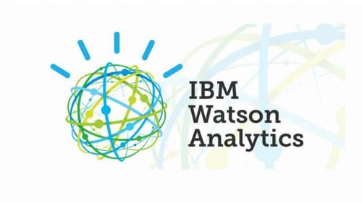
“Watson” is an IBM supercomputer that combines Artificial Intelligence (AI) and complex inquisitive programming for ideal execution as a “question answering” machine. The supercomputer is named for IBM’s founder, Thomas J. Watson.
IBM Watson is at the forefront of the new era of computing. At the point when IBM Watson made, IBM communicated that “more than 100 particular techniques are used to inspect perceive sources, find and make theories, find and score affirm, and combination and rank speculations.” recently, the Watson limits have been expanded and the way by which Watson works has been changed to abuse new sending models (Watson on IBM Cloud) and propelled machine learning capacities and upgraded hardware open to architects and authorities. It isn’t any longer completely a request answering figuring system arranged from Q&A joins yet can now ‘see’, ‘hear’, ‘read’, ‘talk’, ‘taste’, ‘translate’, ‘learn’ and ‘endorse’.

Machine Learning

Introduction
Machine learning is a subfield of artificial intelligence (AI). The goal of machine learning generally is to understand the structure of data and fit that data into models that can be understood and utilized by people.
Although machine learning is a field within computer science, it differs from traditional computational approaches. In traditional computing, algorithms are sets of explicitly programmed instructions used by computers to calculate or problem solve. Machine learning algorithms instead allow for computers to train on data inputs and use statistical analysis in order to output values that fall within a specific range. Because of this, machine learning facilitates computers in building models from sample data in order to automate decision-making processes based on data inputs.
Any technology user today has benefitted from machine learning. Facial recognition technology allows social media platforms to help users tag and share photos of friends. Optical character recognition (OCR) technology converts images of text into movable type. Recommendation engines, powered by machine learning, suggest what movies or television shows to watch next based on user preferences. Self-driving cars that rely on machine learning to navigate may soon be available to consumers.
Machine learning is a continuously developing field. Because of this, there are some considerations to keep in mind as you work with machine learning methodologies, or analyze the impact of machine learning processes.
In this tutorial, we’ll look into the common machine learning methods of supervised and unsupervised learning, and common algorithmic approaches in machine learning, including the k-nearest neighbor algorithm, decision tree learning, and deep learning. We’ll explore which programming languages are most used in machine learning, providing you with some of the positive and negative attributes of each. Additionally, we’ll discuss biases that are perpetuated by machine learning algorithms, and consider what can be kept in mind to prevent these biases when building algorithms.

Machine Learning Methods
In machine learning, tasks are generally classified into broad categories. These categories are based on how learning is received or how feedback on the learning is given to the system developed.
Two of the most widely adopted machine learning methods are supervised learning which trains algorithms based on example input and output data that is labeled by humans, and unsupervised learning which provides the algorithm with no labeled data in order to allow it to find structure within its input data. Let’s explore these methods in more detail.

Supervised Learning
In supervised learning, the computer is provided with example inputs that are labeled with their desired outputs. The purpose of this method is for the algorithm to be able to “learn” by comparing its actual output with the “taught” outputs to find errors, and modify the model accordingly. Supervised learning therefore uses patterns to predict label values on additional unlabeled data.
For example, with supervised learning, an algorithm may be fed data with images of sharks labeled as fish and images of oceans labeled as water. By being trained on this data, the supervised learning algorithm should be able to later identify unlabeled shark images as fish and unlabeled ocean images as water.
A common use case of supervised learning is to use historical data to predict statistically likely future events. It may use historical stock market information to anticipate upcoming fluctuations, or be employed to filter out spam emails. In supervised learning, tagged photos of dogs can be used as input data to classify untagged photos of dogs.

Unsupervised Learning
In unsupervised learning, data is unlabeled, so the learning algorithm is left to find commonalities among its input data. As unlabeled data are more abundant than labeled data, machine learning methods that facilitate unsupervised learning are particularly valuable.
The goal of unsupervised learning may be as straightforward as discovering hidden patterns within a dataset, but it may also have a goal of feature learning, which allows the computational machine to automatically discover the representations that are needed to classify raw data.
Unsupervised learning is commonly used for transactional data. You may have a large dataset of customers and their purchases, but as a human you will likely not be able to make sense of what similar attributes can be drawn from customer profiles and their types of purchases. With this data fed into an unsupervised learning algorithm, it may be determined that women of a certain age range who buy unscented soaps are likely to be pregnant, and therefore a marketing campaign related to pregnancy and baby products can be targeted to this audience in order to increase their number of purchases.
Without being told a “correct” answer, unsupervised learning methods can look at complex data that is more expansive and seemingly unrelated in order to organize it in potentially meaningful ways. Unsupervised learning is often used for anomaly detection including for fraudulent credit card purchases, and recommender systems that recommend what products to buy next. In unsupervised learning, untagged photos of dogs can be used as input data for the algorithm to find likenesses and classify dog photos together.

Approaches
As a field, machine learning is closely related to computational statistics, so having a background knowledge in statistics is useful for understanding and leveraging machine learning algorithms.
For those who may not have studied statistics, it can be helpful to first define correlation and regression, as they are commonly used techniques for investigating the relationship among quantitative variables. Correlation is a measure of association between two variables that are not designated as either dependent or independent. Regression at a basic level is used to examine the relationship between one dependent and one independent variable. Because regression statistics can be used to anticipate the dependent variable when the independent variable is known, regression enables prediction capabilities.
Approaches to machine learning are continuously being developed. For our purposes, we’ll go through a few of the popular approaches that are being used in machine learning at the time of writing.

k-nearest neighbor
The k-nearest neighbor algorithm is a pattern recognition model that can be used for classification as well as regression. Often abbreviated as k-NN, the k in k-nearest neighbor is a positive integer, which is typically small. In either classification or regression, the input will consist of the k closest training examples within a space.
We will focus on k-NN classification. In this method, the output is class membership. This will assign a new object to the class most common among its k nearest neighbors. In the case of k = 1, the object is assigned to the class of the single nearest neighbor.
Let’s look at an example of k-nearest neighbor. In the diagram below, there are blue diamond objects and orange star objects. These belong to two separate classes: the diamond class and the star class.

When a new object is added to the space — in this case a green heart — we will want the machine learning algorithm to classify the heart to a certain class.
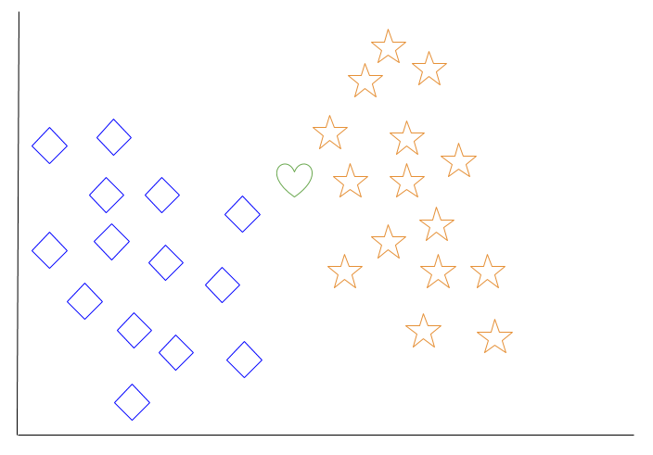
When we choose k = 3, the algorithm will find the three nearest neighbors of the green heart in order to classify it to either the diamond class or the star class.
In our diagram, the three nearest neighbors of the green heart are one diamond and two stars. Therefore, the algorithm will classify the heart with the star class.
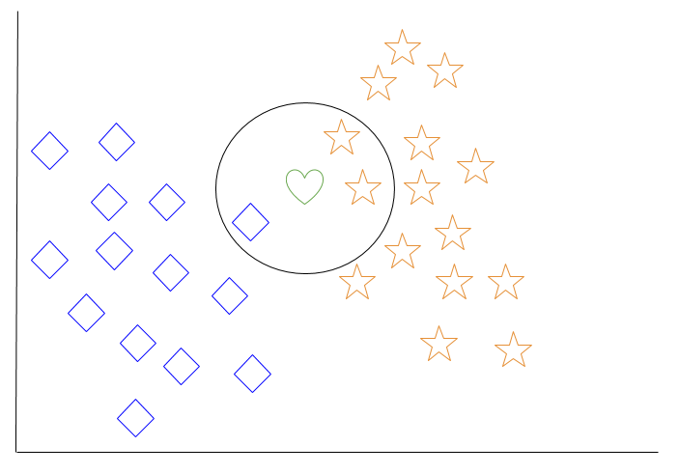
Among the most basic of machine learning algorithms, k-nearest neighbor is considered to be a type of “lazy learning” as generalization beyond the training data does not occur until a query is made to the system.

Decision Tree Learning
For general use, decision trees are employed to visually represent decisions and show or inform decision making. When working with machine learning and data mining, decision trees are used as a predictive model. These models map observations about data to conclusions about the data’s target value.
The goal of decision tree learning is to create a model that will predict the value of a target based on input variables.
In the predictive model, the data’s attributes that are determined through observation are represented by the branches, while the conclusions about the data’s target value are represented in the leaves.
When “learning” a tree, the source data is divided into subsets based on an attribute value test, which is repeated on each of the derived subsets recursively. Once the subset at a node has the equivalent value as its target value has, the recursion process will be complete.
Let’s look at an example of various conditions that can determine whether or not someone should go fishing. This includes weather conditions as well as barometric pressure conditions.
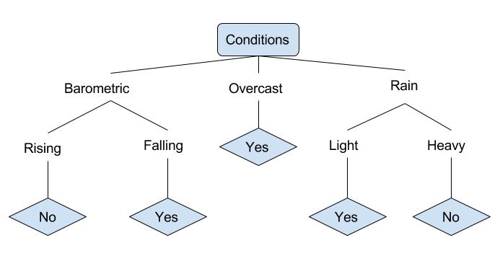
In the simplified decision tree above, an example is classified by sorting it through the tree to the appropriate leaf node. This then returns the classification associated with the particular leaf, which in this case is either a Yes or a No. The tree classifies a day’s conditions based on whether or not it is suitable for going fishing.
A true classification tree data set would have a lot more features than what is outlined above, but relationships should be straightforward to determine. When working with decision tree learning, several determinations need to be made, including what features to choose, what conditions to use for splitting, and understanding when the decision tree has reached a clear ending.

Introduction to Deep Learning
What is deep learning
Deep learning is a branch of machine learning which is completely based on artificial neural networks, as neural network is going to mimic the human brain so deep learning is also a kind of mimic of human brain. In deep learning, we don’t need to explicitly program everything. The concept of deep learning is not new. It has been around for a couple of years now. It’s on hype nowadays because earlier we did not have that much processing power and a lot of data. As in the last 20 years, the processing power increases exponentially, deep learning and machine learning came in the picture.
A formal definition of deep learning is- neurons
Deep learning is a particular kind of machine learning that achieves great power and flexibility by learning to represent the world as a nested hierarchy of concepts, with each concept defined in relation to simpler concepts, and more abstract representations computed in terms of less abstract ones.
In human brain approximately 100 billion neurons all together this is a picture of an individual neuron and each neuron is connected through thousand of their neighbours.
The question here is how do we recreate these neurons in a computer. So, we create an artificial structure called an artificial neural net where we have nodes or neurons. We have some neurons for input value and some for output value and in between, there may be lots of neurons interconnected in the hidden layer.

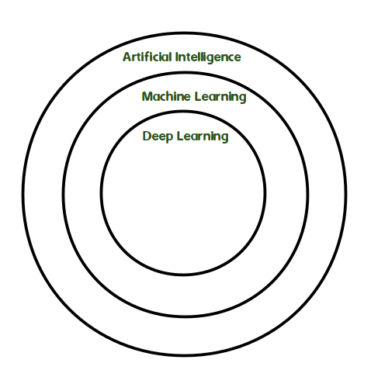

Difference between Machine Learning and Deep Learning :
MACHINE LEARNING | DEEP LEARNING
Works on small amount of Dataset for accuracy. | Works on Large amount of Dataset.
Dependent on Low-end Machine. | Heavily dependent on High-end Machine.
Divides the tasks into sub-tasks, solves them individually and finally combine the results. | Solves problem end to end.
Takes less time to train. | Takes longer time to train.
Testing time may increase. | Less time to test the data.

